
הגלריה לאמנות, בית יגאל אלון, גנוסר
The Yigal Alon Center Art Gallery, Ginosar

Anna Pasternak - "Barefooted"
(Paintings - oil on canvas)

Dina Hoffman - "I Saw Magdalene Sailing"
(An installation – drawings and mixed media)

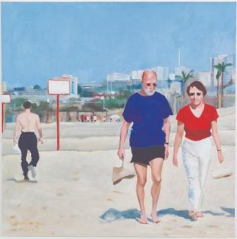
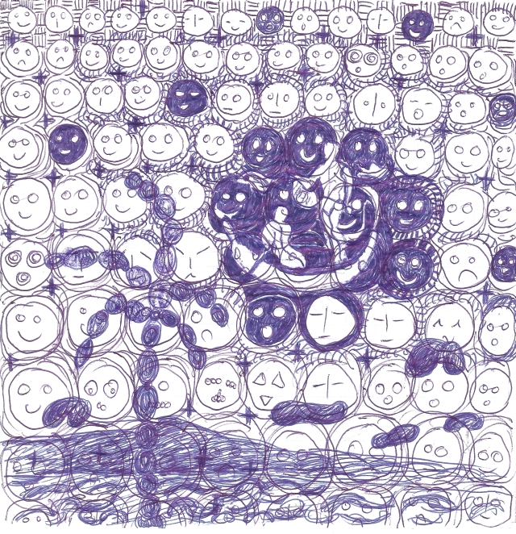

Anna Pasternak Dina Hoffman

Festive opening: Saturday, July 9, 2011, at 12:00 PM

Curator: Nava Harel Shoshani

Anna Pasternak lives in Haifa, in an apartment overlooking the Mediterranean Sea. The sea is constantly present in her home and a large body of works in this exhibition deals with the sea and the people visiting it. Anna paints out of profound observation, out of enthusiasm that awakes in her by people in motion, sights and colors. The drive for her work is a visual experience, real, authentic and vivid.
Anna Pasternak is participating in the 54th Art Biennale in Venice, 2011, in the Italian Pavilion. She exhibited in the Tel Aviv Museum of Art, 2010, in the Mishkan Le’Omanut, Museum of Art, Ein Harod, 2006, and more.
Dina Hoffman was born in Kibbutz Ein-gev and grew up right next to the Kinneret, that set a magical stage décor to her childhood. In this exhibition she goes on a journey through the natural scenery which is her home, a childhood and mental scenery. This journey can be looked at as a life parable and perhaps a sort of farewell. In both bodies of work, she refers to images and occurrences of hers in and around the lake.
Dina took part in many exhibitions and in the passing year presented a single exhibition in the Nahum Guttman Museum in Tel-aviv, also dealing with the Kinneret.

Free entrance to the exhibitions

The Yigal Alon Center, opening hours: Sun – Thurs. & Saturday 8:30 – 16:00
Friday: 8:30 – 15:00. www.bet-alon.co.il Tel. : 04-6727700

